**Docker Task**

Install docker on EC2 and explore the docker commands (docker images, containers, volumes, network)

Install docker on EC2

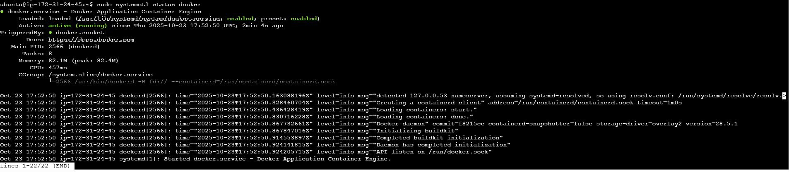

Docker Version



Docker Info:

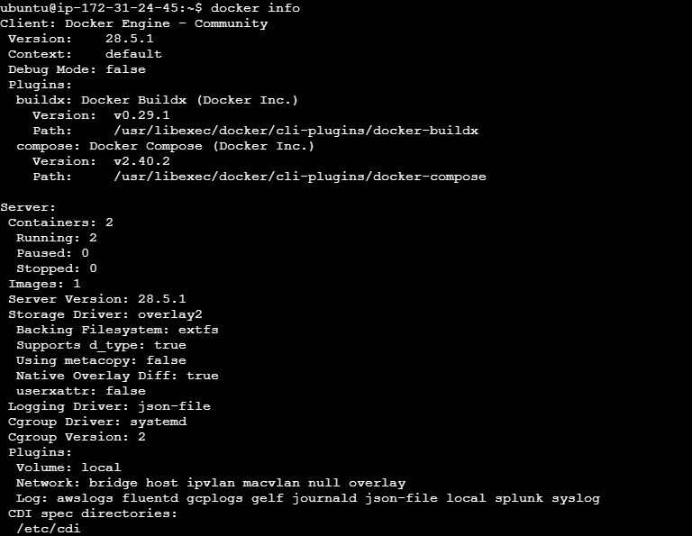

docker pull

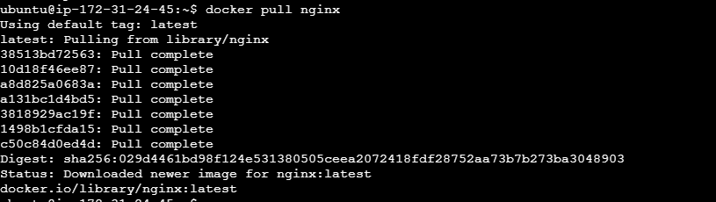

docker images

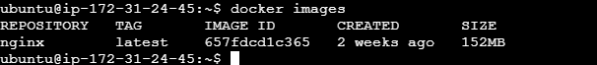

Run a container:



List running containers:



List all containers



Volumes:

Create a volume:



List volumes:



Inspect a volume:

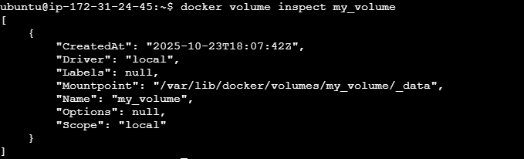

Use a volume with a container:



Network

Create a custom network:



Inspect a network:

